Name

Mathematics Advanced Year 11
Piecewise-Defined Functions

Book 1 |  | Version: 261007  Feedback:  https://MrDingMaths.com
Contents
Syllabus Content 2
Learning Intention 3

Syllabus Content
MAV-11-02 uses functions and relations to model, analyse and solve problems
Piecewise-defined functions
- Interpret piecewise-defined functions, where the function is defined differently in different parts of the domain
- Graph piecewise-defined functions involving functions covered in the scope of the Mathematics Advanced course, test if they are even or odd, and determine the domain and range
- Define informally that a function is continuous at a point if the curve can be drawn through the point without lifting the pen off the paper
- Identify points where piecewise-defined functions and other functions are not continuous
- Define a discontinuity of a function informally as a point where the function is not continuous

Piecewise-Defined Function

- Piecewise-Defined Function
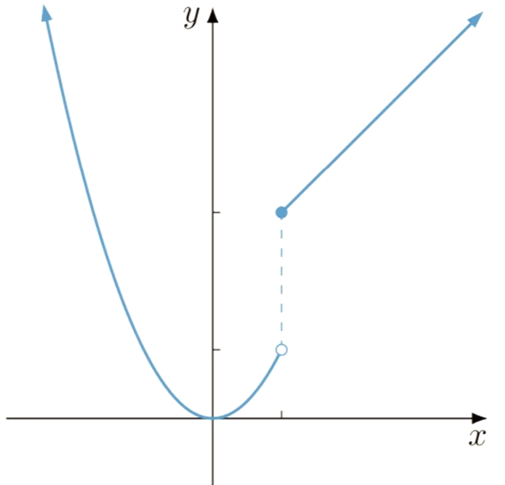
- A piecewise function combines more than one function in different parts of its domain.
$$f\left(x\right)=\left\{\begin{aligned}g\left(x\right), x≤a \\ h\left(x\right), x>a \end{aligned}\right.$$

- $f(x)$ is called the piecewise-defined function.
- $g(x)$ and $h(x)$ are called subfunctions.
- To sketch a piecewise-defined function:
- Identify the graphs of each subfunction and their domains.
- Calculate function values at the boundaries.
- Sketch each subfunction separately.
Decide whether to connect the curves or use open/closed circles.

- Example Sketch a piecewise-defined function
$$f\left(x\right)=\left\{\begin{aligned}4-x^{2}, x≤0 \\ 4+x, x>0\end{aligned}\right.$$  1. Let $g\left(x\right)=4-x^{2}$ and $h\left(x\right)=4+x$  $g\left(x\right):$ concave down parabola, vertex $\left(0,4\right)$  $h\left(x\right)$: increasing straight-line.  2. $g\left(0\right)=4$, $h\left(0\right)=4$  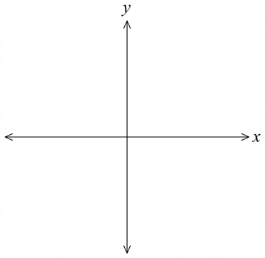  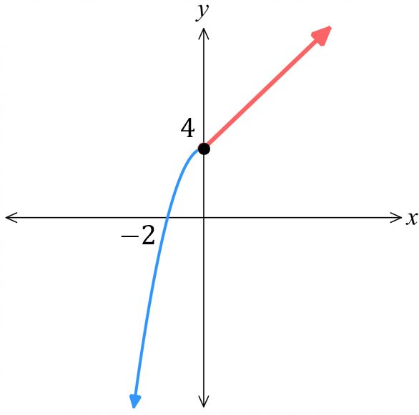  3. | $$f\left(x\right)=\left\{\begin{aligned}2^{x}, x<1 \\ x^{2}, x≥1\end{aligned}\right.$$  1. Let $g\left(x\right)=2^{x}$ and $h\left(x\right)=x^{2}$  $g\left(x\right):$ exponential growth, intercept (0,1)  $h\left(x\right):$ concave up parabola, vertex (0,0)  2. $g\left(1\right)=2$, $h\left(1\right)=1$  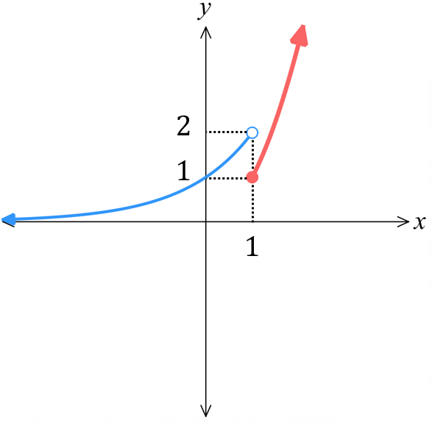  3.

- Guided Practice
Sketch:
$$f\left(x\right)=\left\{\begin{aligned}1+x, x≤0 \\ 1-x, x>0\end{aligned}\right.$$  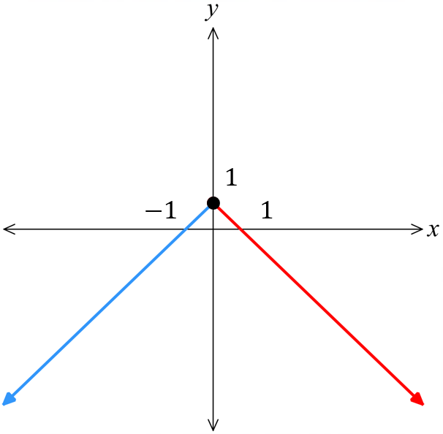 | $$f\left(x\right)=\left\{\begin{aligned}-x, x≤0 \\ x^{2}+1, x>0\end{aligned}\right.$$  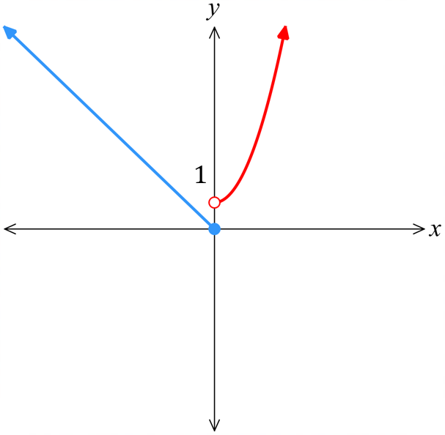
$$f\left(x\right)=\left\{\begin{aligned}2^{x}, x≤0 \\ \frac{1}{x}, x>0\end{aligned}\right.$$  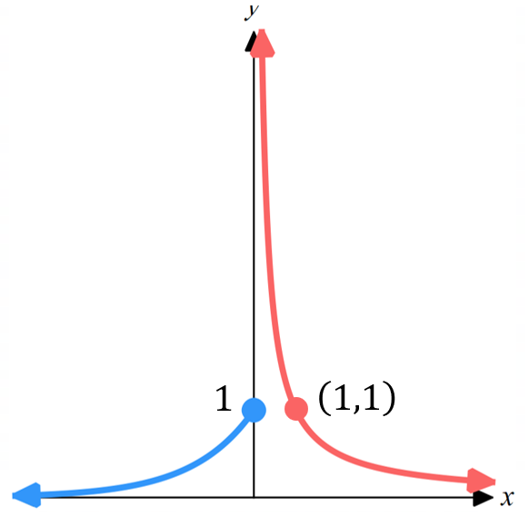 | $$f\left(x\right)=\left\{\begin{aligned}\begin{aligned}-x, x<-1 \\ x^{2}, -1≤x<1 \end{aligned} \\ x+1 x>1 \end{aligned}\right.$$  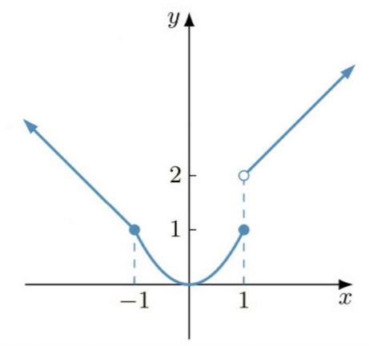

Foundation
- Sketch the following piecewise-defined functions.
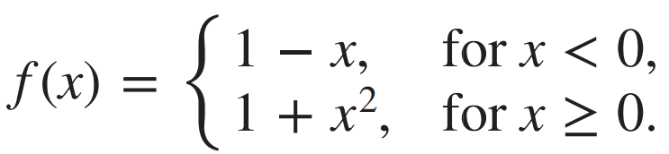  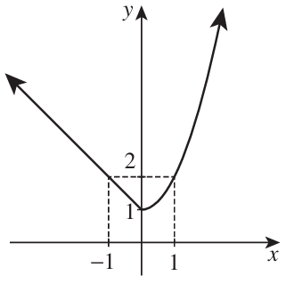 | 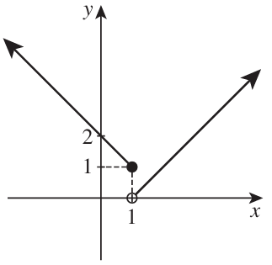  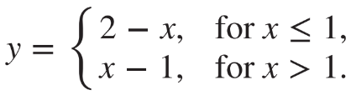
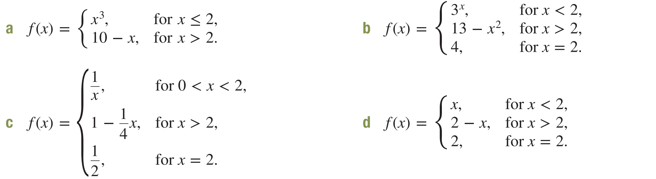  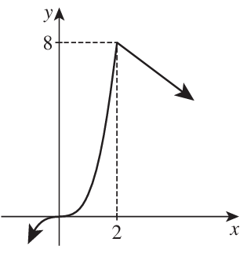 | 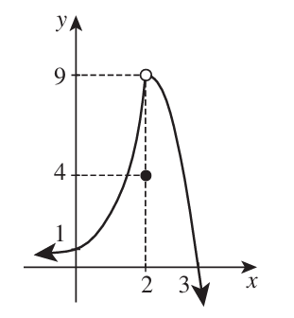
- Sketch these piecewise functions.
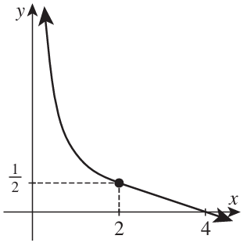 | 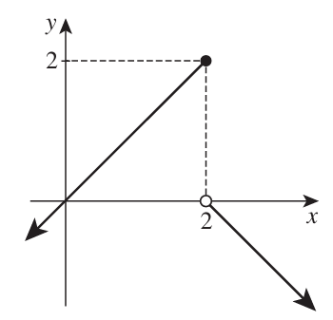

Development
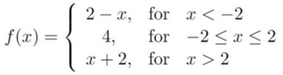
- Consider the piecewise-defined function:

Evaluate:
- $f\left(0\right)$  4 | - $f\left(5\right)$  7 | - $f\left(-3\right)$  5 | - $f\left(3\right)-f\left(-1\right)$  1

- Consider the piecewise defined function and evaluate:
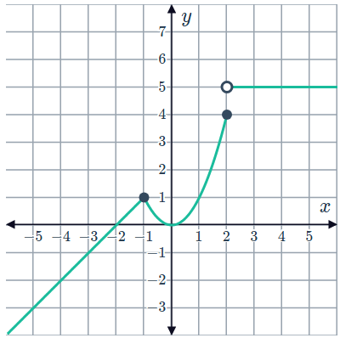
  - $f\left(-1\right)$
$$1$$
  - $f\left(4\right)$
$$5$$
  - $f\left(2\right)$
$$4$$
  - $f\left(-4\right)-f\left(3\right)$
$$-7$$

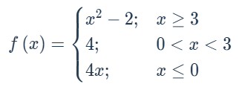
- Consider the piecewise defined function and evaluate:

- $f\left(4\right)$  14 | - $f\left(0.5\right)$  4 | - $f\left(-3\right)$  $$-12$$ | - $f\left(a\right)$, where $a$ is negative  $$4a$$

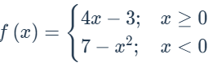
- Consider the piecewise defined function and evaluate:

- $f\left(5\right)-f\left(-5\right)$  35 | - $6f\left(6\right)$  126 | - $f(a^{2})$  $$4a^{2}-3$$

Mastery
- Sketch these piecewise-defined functions and state their range.
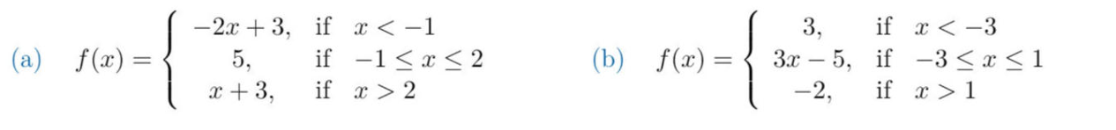  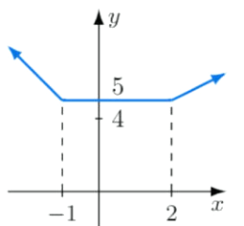  $$R:\left[5,∞\right)$$ | 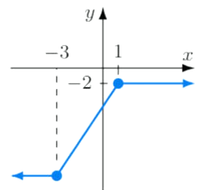  $$R:\left(-∞,-2\right]$$
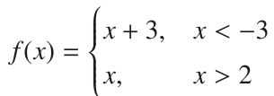  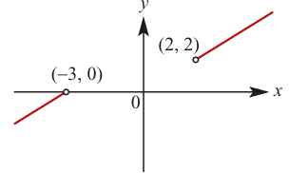  $$R:\left(-∞,0\right)∪\left(2,∞\right)$$ | 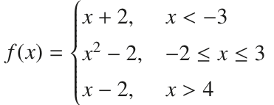  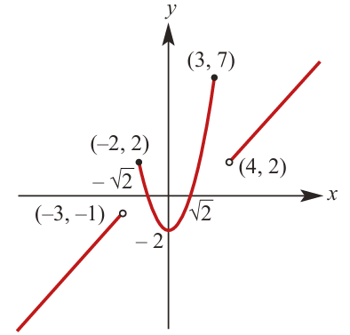  $$R:\left(-∞,-2\right]$$

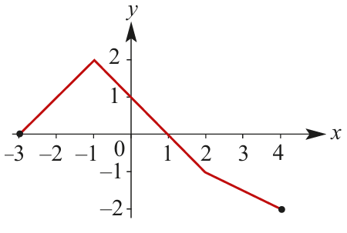
- Specify the function represented by this graph:

$$f\left(x\right)=\left\{\begin{aligned}x+3, -3≤x≤-1 \\ -x+1, -1<x≤2 \\ -\frac{x}{2}, 2<x≤4 \end{aligned}\right.$$

Continuous at a Point

- Continuous at a Point
A function is continuous at a point $x=a$ if the graph of $y=f\left(x\right)$ can be drawn through the point in a single pen stroke without lifting the pen.
In the graph below, the function is continuous everywhere except for the discontinuities at $x∈\left\{c, d, e, f\right\}$.
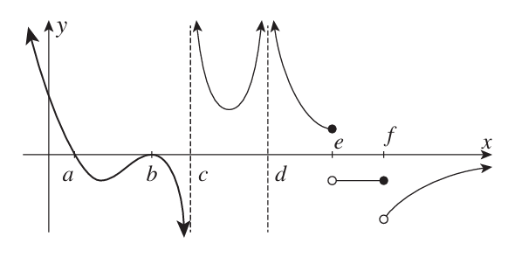

- Identify discontinuities in graphs.
Identify any discontinuities in these curves, if any.
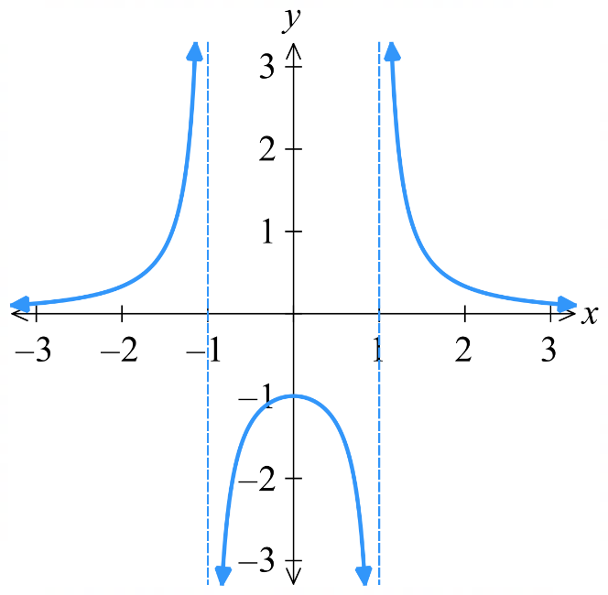
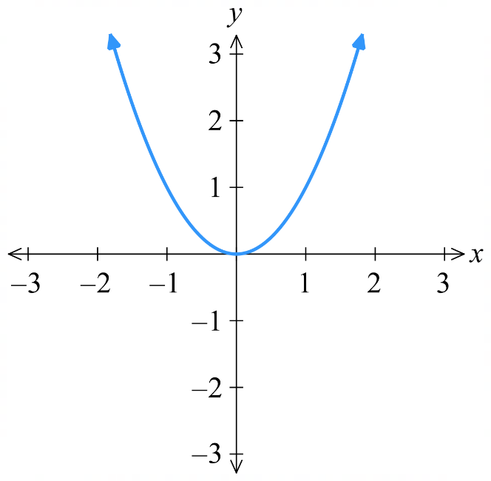
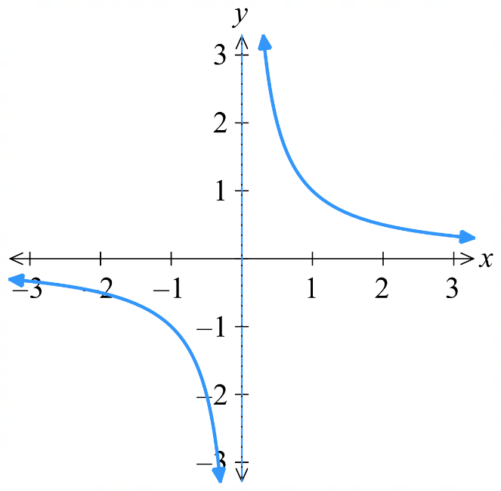

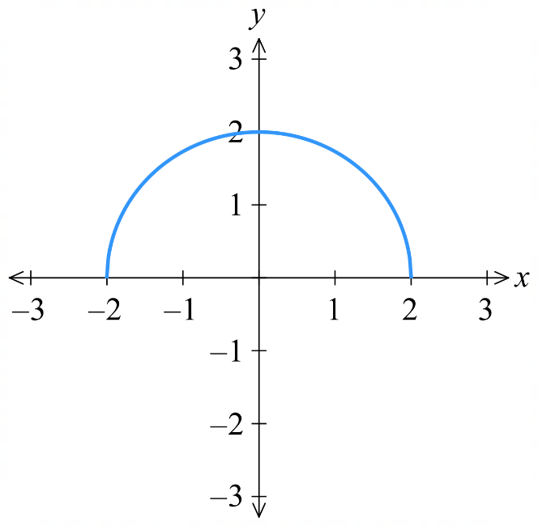 | 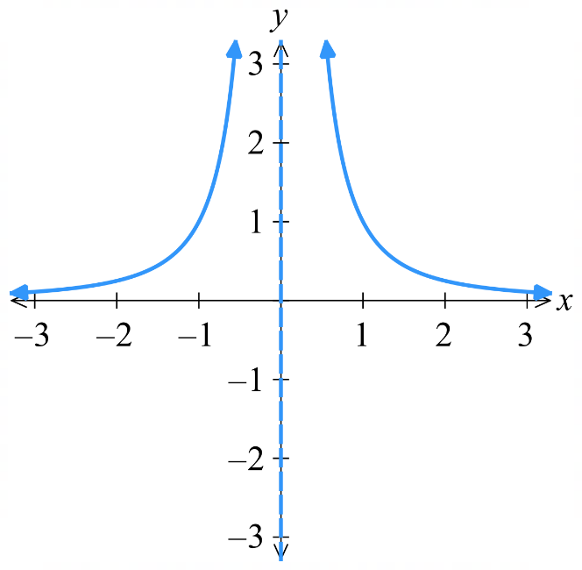 | 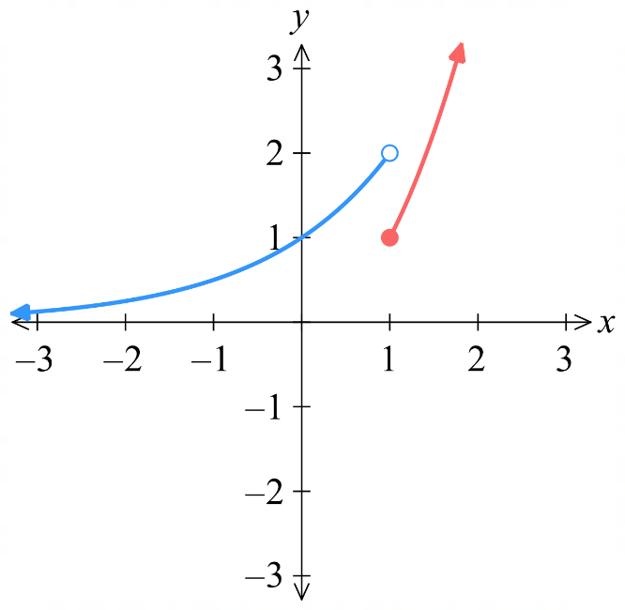

- Continuous from an Equation
A function is discontinuous at $x=a$ if:
- The function is undefined at that point (e.g. asymptote, denominator = 0).
- A piecewise function doesn’t join up at $x=a.$

Given a piecewise function:
$$f\left(x\right)=\left\{\begin{aligned}g\left(x\right), x≤a \\ h\left(x\right), x>a \end{aligned}\right.$$
The function is continuous at $x=a$ if $g\left(a\right)=h(a)$.
The function is discontinuous at $x=a$ if $g\left(a\right)≠h(a)$.

We will assume the curve is continuous everywhere else.

- Example Determine continuous from an equation.
Decide whether these functions are continuous at $x=1$ using the equation. A sketch is given.
$$f\left(x\right)=\frac{3x-3}{4x-4}$$  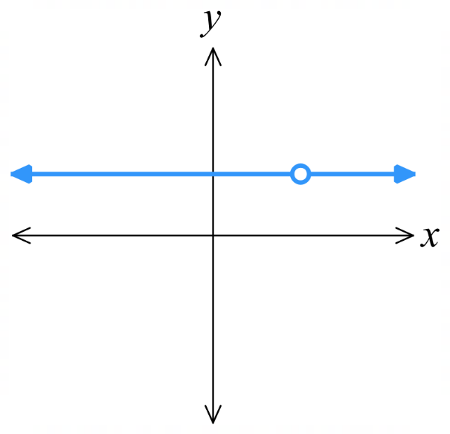  $f\left(x\right)$ is undefined when $4x-4=0$  $x=1$  Since $f\left(x\right)$ is undefined at $x=1$, it is not continuous at $x=1$. | $$f\left(x\right)=\left\{\begin{aligned}2-x, x<1 \\ x^{2}, x≥1\end{aligned}\right.$$  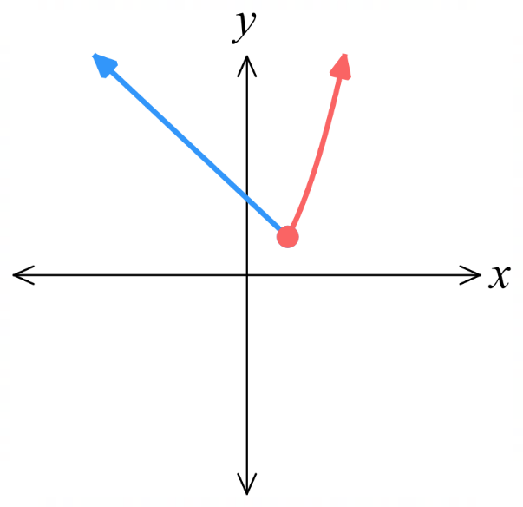  Let $g\left(x\right)=2-x$  $$g\left(1\right)=1$$  Let $h\left(x\right)=x^{2}$  $$h\left(1\right)=1$$  The graphs join up at $x=1$, $∴$ continuous.

- Practice
Decide whether these functions are continuous at $x=3$.
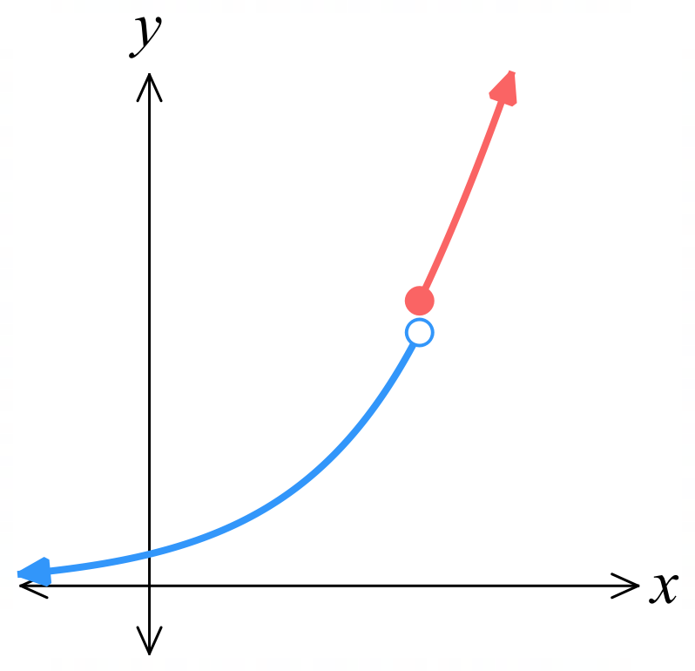  $f\left(x\right)=\left\{\begin{aligned}2^{x}, x<3 \\ x^{2}, x≥3\end{aligned}\right.$  Discontinuity at $x=3$ | $$f\left(x\right)=\frac{5}{x^{2}-4}$$  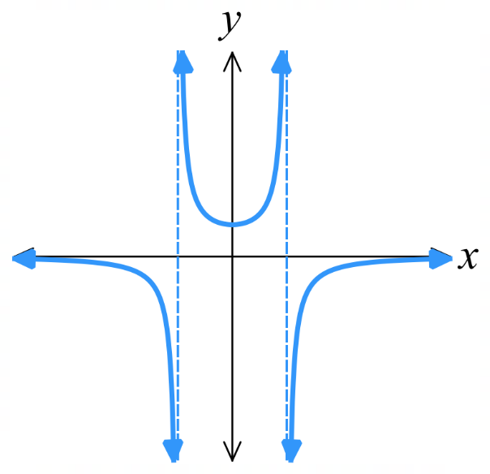  Continuous at $x=3$

Foundation
- State whether each function is continuous at the given point.
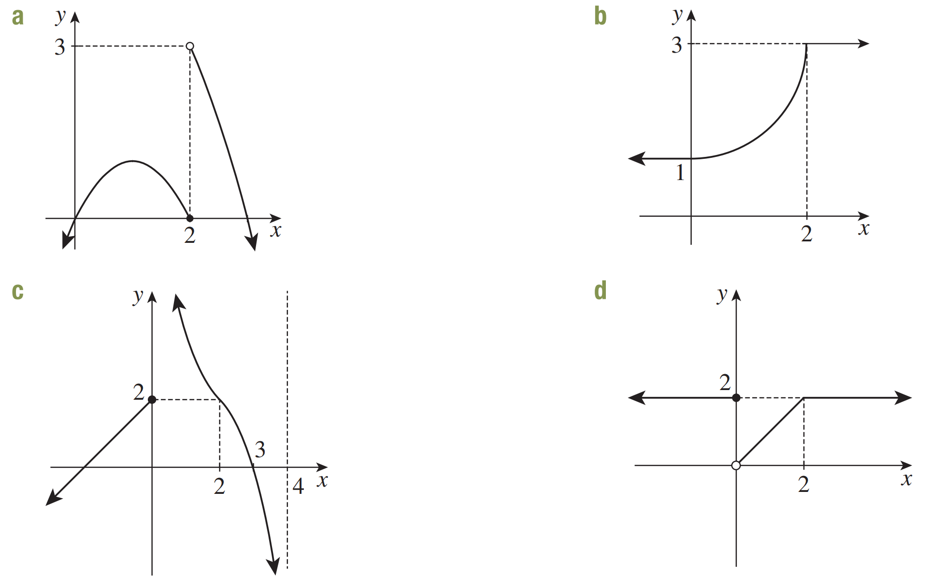  - $x=2$  Discontinuous | - $x=2$  Continuous | - $x=0$  Discontinuous | - $x=2$  Continuous

- For these functions, state whether the function is continuous throughout its domain. If not, identify the $x$ value(s) where the function has a discontinuity.
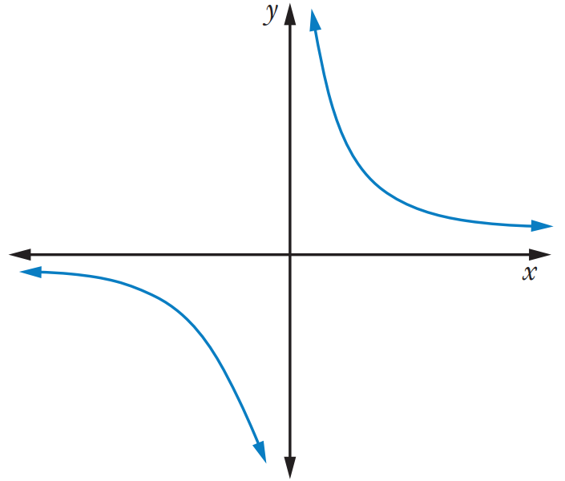  discontinuity at $x=0$ | 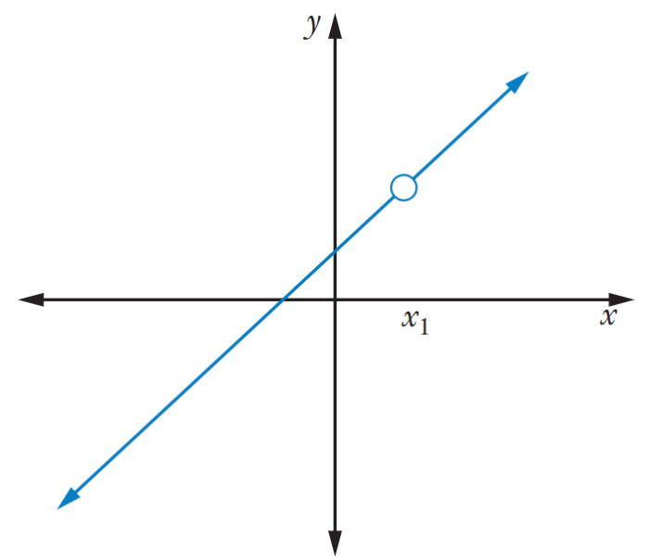  discontinuity at $x=x_{1}$ | 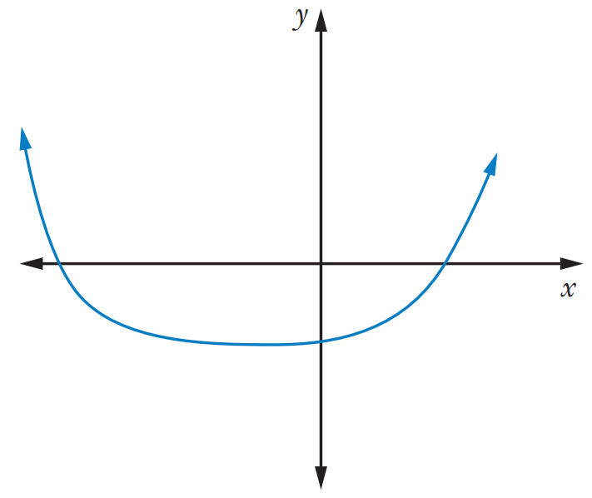  continuous function
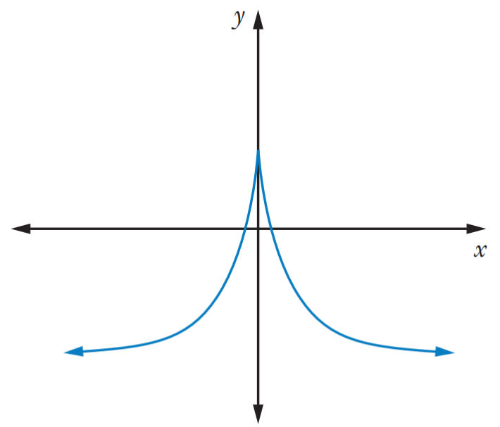  continuous function | 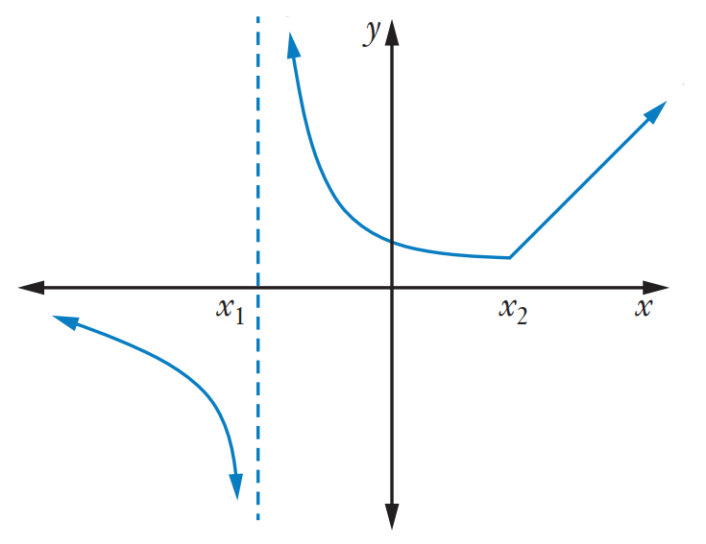  discontinuity at $x=x_{1}$ | 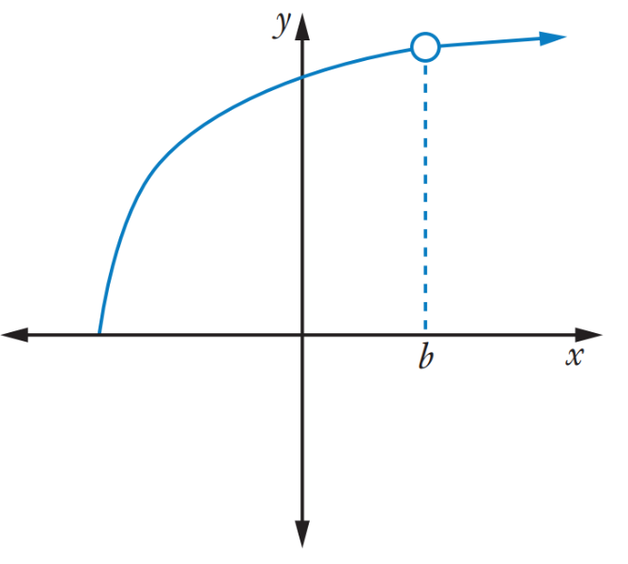  discontinuity at $x=b$

- State the values of $x$ at which a discontinuity occurs.
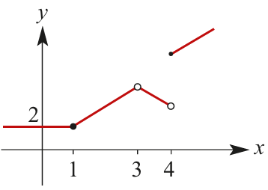  $$x=3 and 4$$ | 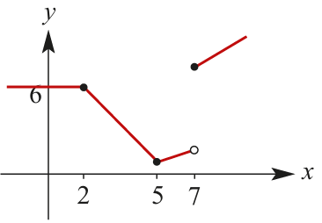  $$x=7$$
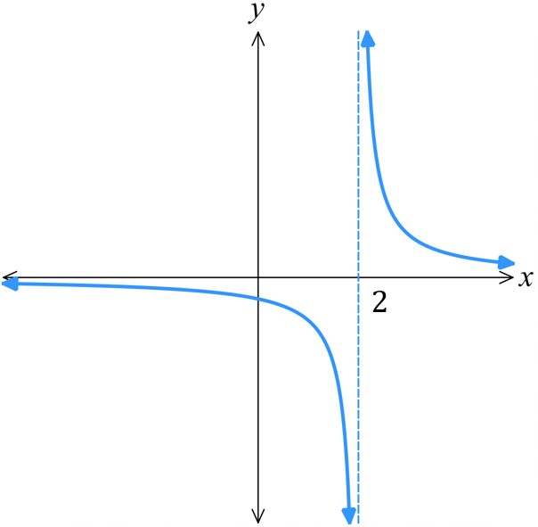  $$x=2$$ | 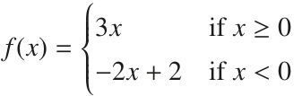  $$x=0$$
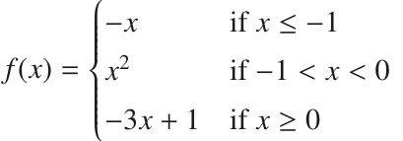  $$x=0$$ | 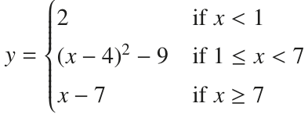  $$x=1$$

Development
- Consider the graph of $y=f\left(x\right)$.
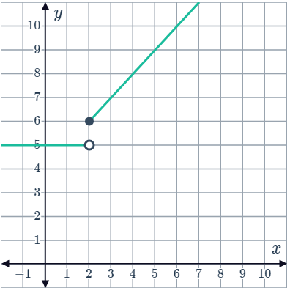  - What is the function value at $x=2$?  6  - Is the graph continuous at $x=2$?  no | 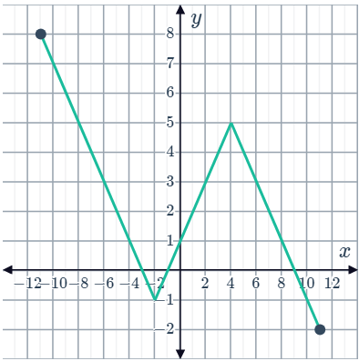  - What is the function value at $x=4$?  5  - Is the graph continuous at $x=4$?  yes

- Determine where the function is discontinuous, using your knowledge of asymptotes and/or natural domains. Check your answer using DESMOS.
$$f\left(x\right)=\frac{5}{6-x}$$  $$x=6$$ | $$f\left(x\right)=\frac{3x}{(x-1)(x-3)(x-5)}$$  $$x=1, 3, 5$$ | $$f\left(x\right)=\frac{x(x+1)}{(x+1)(x+3)}$$  $$x=-1,-3$$
$$f\left(x\right)=\frac{5}{x^{2}-5x}$$  $$x=0, 5$$ | $$f\left(x\right)=\frac{x}{x^{2}-5x+6}$$  $$x=3, 2$$ | $$f\left(x\right)=\frac{x^{2}-16}{x^{2}-9}$$  $$x=-3, 3$$

